Description
Property Data Engineering Competition Sprint - Part 1
Introduction
Welcome to the Property Analysis Competition Sprint! This project follows industry best practices for Business Intelligence development and is designed to help interns gain comprehensive experience with end-to-end BI solutions. While the instructions outline what needs to be accomplished, they intentionally leave room for you to develop problem-solving skills by determining how to implement these requirements based on your 6-week training and onboarding experience.
Dataset Resources
Download the following three Excel files from the RawDataSet link:
- AUS_SubCityDistrictState_Data
- NSW_PropertyMedianValue
- NSW-Public-Schools-Master-Dataset
Part 1: Data Engineering
Task Overview: Design a Data Warehouse, Data Model, and ETL/ELT Pipeline
1. Data Acquisition
- Download the three datasets from the RawDataSet link
- Familiarize yourself with the data structure and content of each file
2. Initial Data Loading with SSIS
- Create a new SSIS package in Visual Studio
- Design dataflows to extract data from all three source files
- Load the extracted data into staging tables in your Data Warehouse
- Use the "load_" prefix for all staging table names
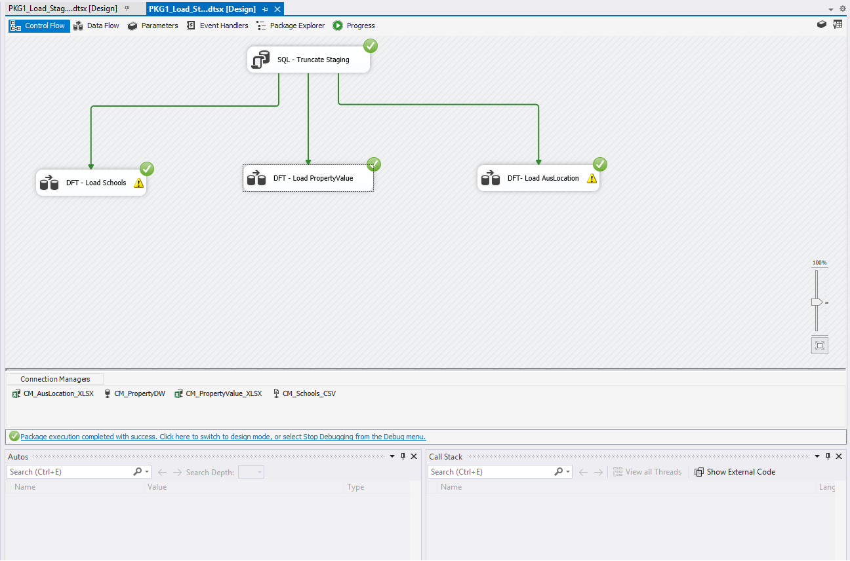

3. Dimensional Modeling
- Follow Kimball's dimensional modeling methodology
- Design either a Snowflake Schema or Star Schema model
- Create appropriate dimension and fact tables
- Use a Bus Matrix to identify necessary dimension and fact tables
- If using Star Schema, research and consider implementing factless fact tables where appropriate
4. Data Transformation Pipeline
- Create a second SSIS package
- Design dataflows to extract data from staging tables
- Transform the data according to business requirements
- Load the transformed data into your Snowflake or Star Schema model
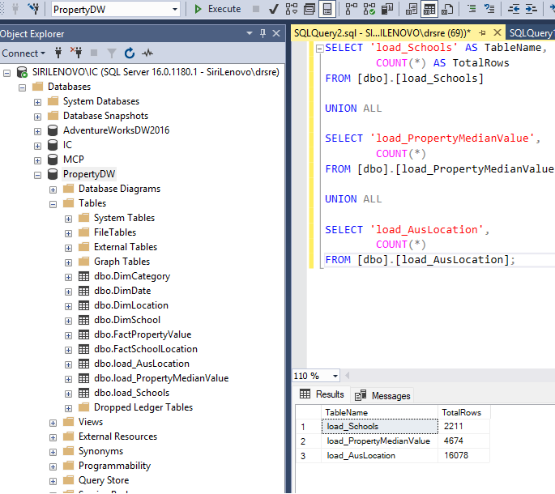

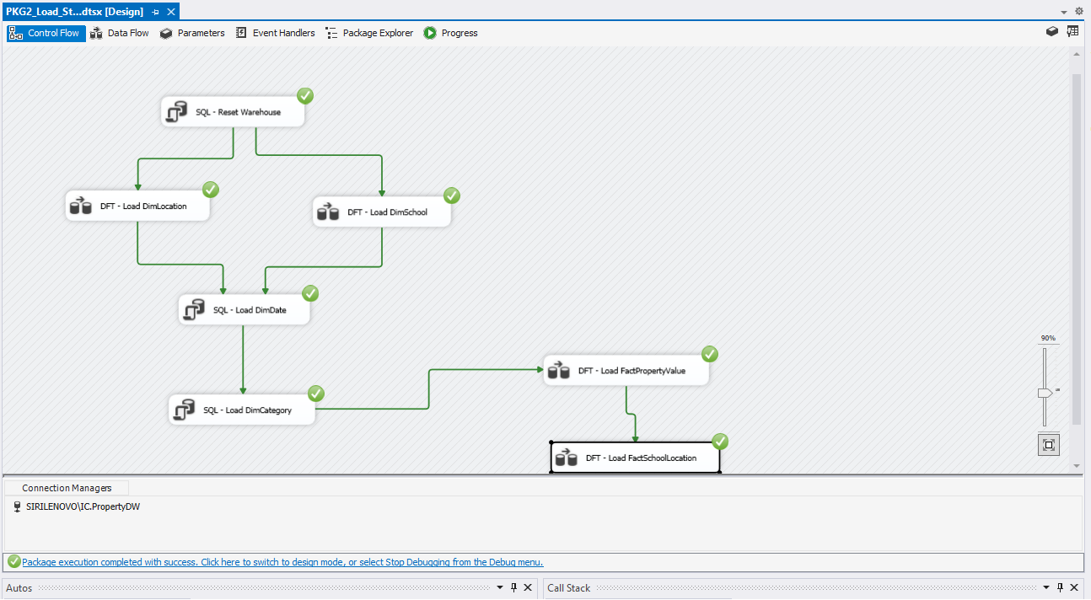
5. Property Value Categorization
- Create a "Category" dimension table (or use as a degenerate dimension in fact tables)
- Implement a transformation in SSIS to categorize Median Property Values into:
- $0-$750K
- $750K-$1.5M
- $1.5M-$2.5M
- $2.5M+
- Load these category values into the appropriate dimension or fact tables
